Chapter3
The New Discoveries (Summary):
The Engineering Observations

The EMA0 exhibits several important construction details, many of which have not been observed from the surviving technical crumbs of this engine’s design. We shall point these out and then go back to expand and speculate upon their importance later on. (Chapters 4-6)

Full Length Electromagnet Mounting Base Plates

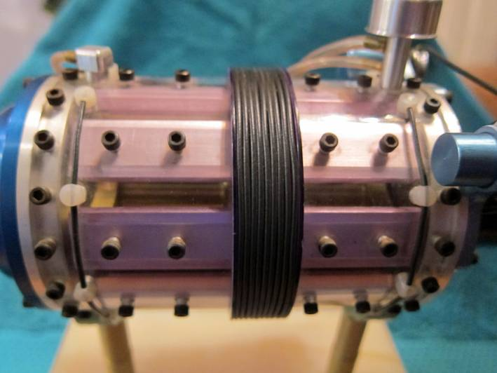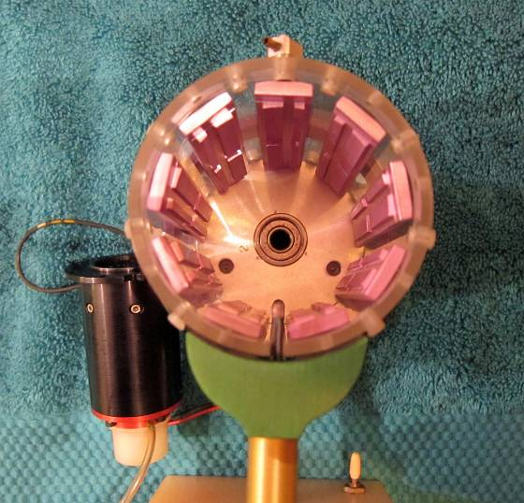
Closer outside view of the 9 electromagnetic Base Plates View of the Base Plates with the End Cap removed

The modeled aluminum mounting pads for the stator electromagnets (made of magenta anodized aluminum) in the EMA0 are the full length of the engine case. In the past it had been thought that on the EMA4 engine these were separated in to two sections (front & back) - like the rotor electromagnets. This greatly impacts the various theories that speculate on the actual topology of the stator wiring
.
The model’s Base Plates are secured with four screws (the original machine uses six). If there were individual front and back Base Plates then it would have been much simpler to line up 2 holes rather than 4 holes. This strongly supports the idea that a continuous extruded bar of aluminum was used in the full sized machine. The photos of the full size EMA4 available to date do not disclose the complete construction of the actual Base Plates since they are covered with dielectric blocks.

In the EMA0 these long base plates have been machined with scaled protrusions to show the “Major” and “Minor” electromagnets. The tops of these modeled electromagnets have then been re-milled to match the radius of the Rotor Assembly. It is odd that these features this small are included in this model’s fabrication since they can barley be seen from the out side. Together there are 9 sets of base plates that are composed of 4 electromagnets each – 2 “Minor” and 2 “Major”. All 36 stator electromagnets are represented.

In the EMA4 it is thought that the iron laminations that make up the cores of the electromagnets are electrically connected to these aluminum base plates. The base plates then form a capacitor with the electrically conductive metal outer case and are at the same potential as the cores that are dovetailed into them. The 0.250” thick Teflon inner case liner provides for the capacitor dielectric. The over all effect is 9 individual capacitors with the engine case acting as a common ground.

The Three Rotor Buss Bar Rings

The rotor for the full scale EMA4 has never been photographed. This is because it is always inside the Engine Case or out being machined. There was a small view port added in early 1973 but this only allowed a small section of the electromagnets to be seen. Even so, the available photographs are way too fuzzy to make out any usable detail. On the occasion that the EMA4 was disassembled the Rotor Assembly was being re-machined and was not in the shop in April 1974,

The only information about the Rotor Assembly comes from the Pulse Engine Patent. There is no photographic evidence to validate the patent disclosures. The EMA0 model Rotor Assembly may be the best evidence we have to date about construction details of this vital component.

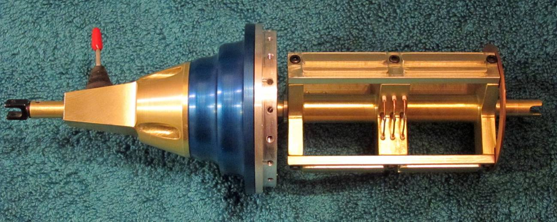

The Rotor Assembly removed from the EMA0 showing unseen construction details.

The removed model Rotor Assembly shows three distinct circular copper buss bar rings in the center of the shaft. These have only been hinted at in the patent documents, but the model clearly shows their location and general layout. These buss rings are mounted through holes machined in the center spider support. The detail in this model also shows tubes of insulation providing voltage isolation between the buss rings and the Rotor Assembly.

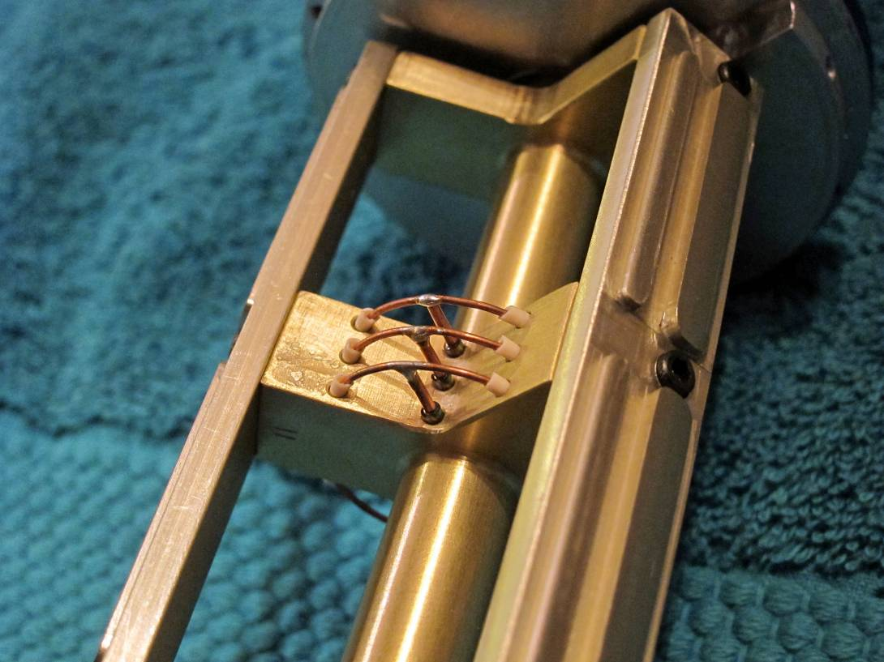
Three well isolated copper bus bar rings in the center of the Rotor Assembly. Consider the hours that were invested in constructing and installing this level of non-functional finished detail.

Front End Slip Ring

This is certainly something new that has not been disclosed in the Pulse Engine Patent, nor seen in any common domain photos. The existence of two external high voltage terminals at the front of the EMA4 engine were specious, but now a much better understanding of their association with the Rotor Assembly can now be seen.

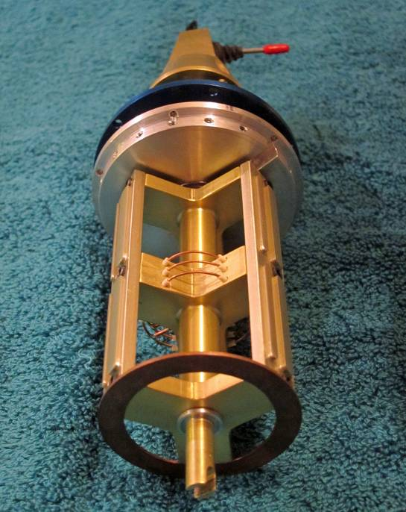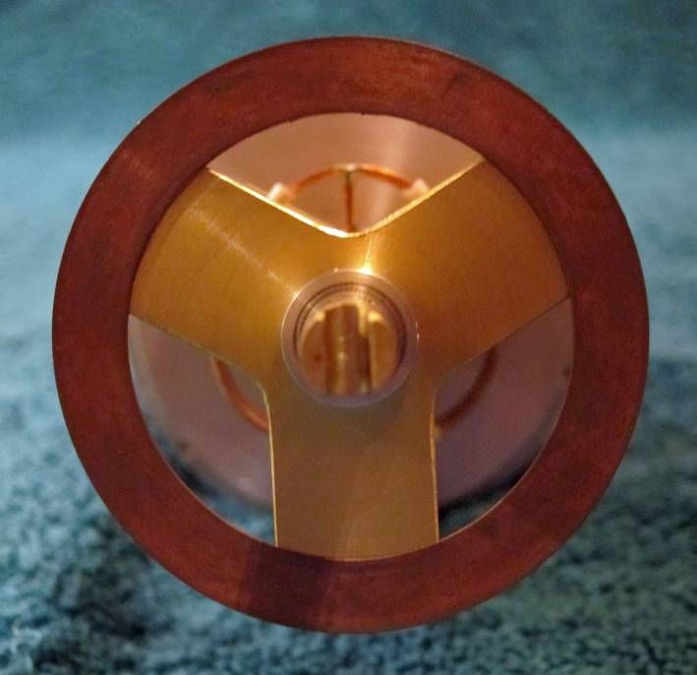

Removed Rotor Assembly as seen from the front Close up view of the modeled “Front End Slip Ring”

The following photos will show hints of the brush holders that were used to make the electrical connections to the Front Slip Ring:
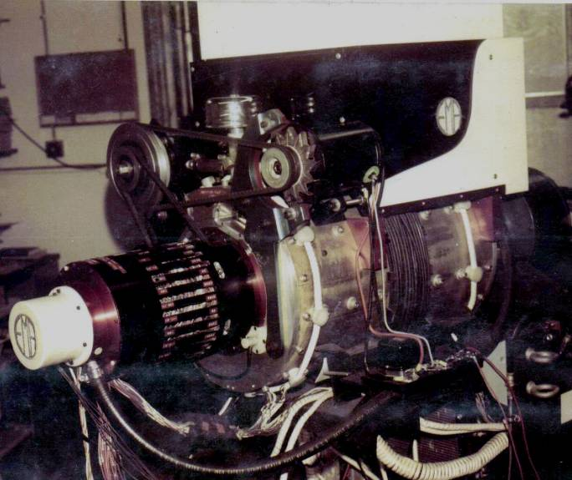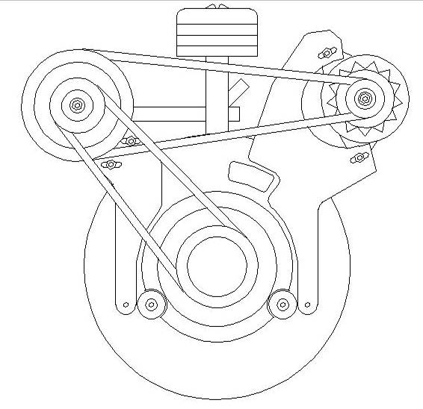

The EMA4-E2 Jan. 17, 1974. Notice the white circular EMA4-E2 Elevation sketch showing the two
terminal at the 4:00 position on the front engine plate. There Front End Slip Ring Brushes at the 4:00 and
is another on the other side at the 8:00 location. 8:00 positions.

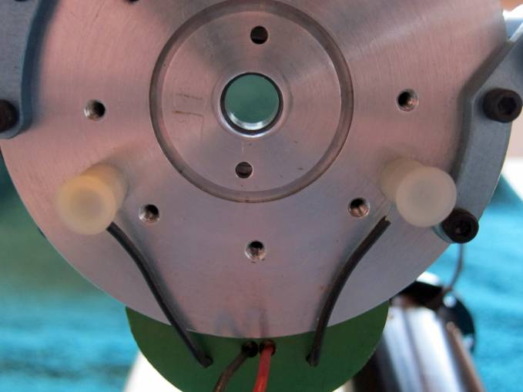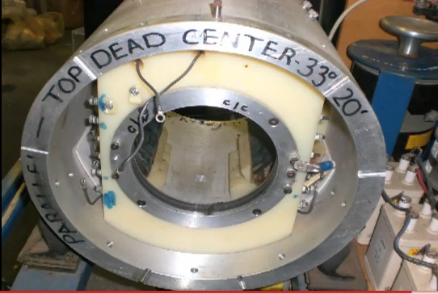

This is how the Front Slip Ring Brush Terminals are This is the Front Slip Ring Assembly for the “Brown
displayed on the EMA0. The front cowling and shaft Motor”. In this early motor version the brushes were
have been removed. mounted on the shaft.

Mr. Hackenberger was once quoted as saying that the rotor of the EMA4 engine only makes contact at three places. Well two of those places are the shaft end bearings. These two contacts with the Rotor Assembly Slip Ring could well be the other.

